**Big Mountain Resort Recommendation Summary**

My goal with this project was to build a predictive model for ticket price based on the facilities which visitors are more likely to pay more for. Using this model I would then advise Big Mountain Resort with their pricing strategy as well as future facility investment plans.

Big Mountain Resort are currently charging $81.00 per person, however my model suggests that a ticket price closer to $95.87 is supported by the facilities that Big Mountain resort currently has. Big Mountain resort is consistently in the top portion of resorts in key features including: vertical drop, snow making area, total number of chairs and fast quads, runs and skiable terrain area. 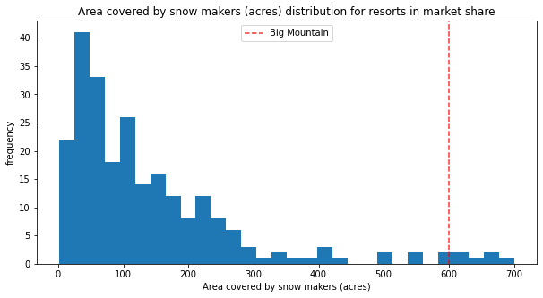

Figure 1: Histogram showing where Big Mountain fits among other resorts in the country for area covered by snow makers in acres.

Figure 1: Histogram showing where Big Mountain fits among other resorts in the country for area covered by snow makers in acres.

When it comes to the options that Big Mountain resort has shortlisted for either cutting costs or increasing revenue (through a supported ticket price increase), I believe 2 are worth investigating further.

The most promising one would be increasing vertical drop by adding a run to a point 150 feet lower than the base and then installing an additional chair lift to bring riders back up. The model shows that this scenario increases support for ticket price by $1.99 which, over the season, could be expected to amount to $3,474,638 in additional revenue.

The other decision was whether or not it would be worth it to permanently shut down up to 10 of the least used runs. Using the model to predict how support for ticket price might change with the loss of runs, I was able to come up with the following:

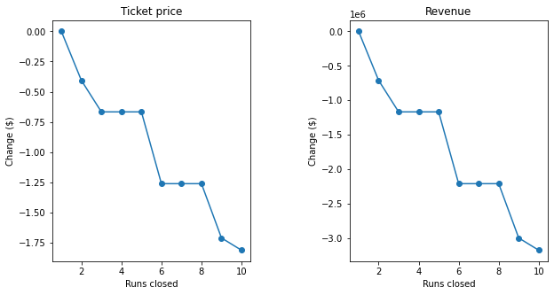

Figure 2: Line graphs showing the change in ticket price and revenue after closing up to 10 runs.

We can see that closing 1 run doesn’t change the ticket price we can support at all. After that we see a drop when closing 2 and another small drop when closing 3. However, after closing 3, the 4th and 5th closure doesn’t affect the ticket price further. Using this information, we can assess whether closing a certain number of runs is beneficial when factoring in how much it could save Big Mountain resort versus how much it would cost them through ticket price.

The functionality of the model also allows anyone with knowledge on how the function works to be able to change parameters and see how that might affect ticket price.